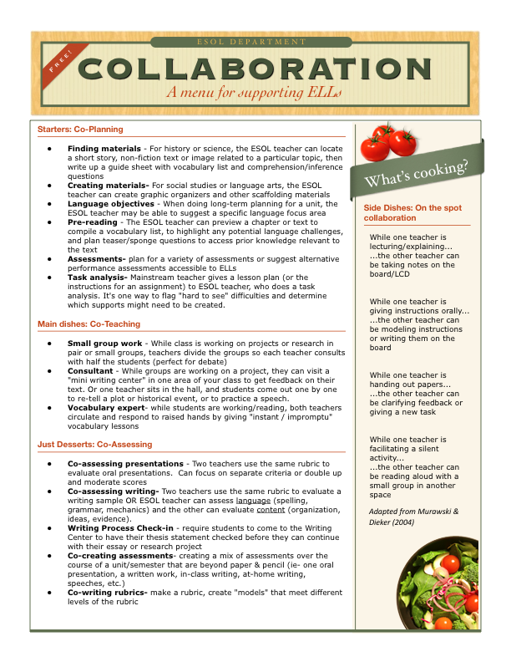

Mulazzi, F., & Nordmeyer, J. (2012). Coteaching as professional development. In A. Honigsfeld and M. G. Dove (Eds.) Coteaching and other collaborative practices in the EFL/ESL classroom: Rationale, research, reflections, and recommendations. Charlotte, NC: Information Age Publishing.

